Ideation Phase
Brainstorm s Idea Prioritization Template
Date 30 June 2025
Team ID LTVIP2025TMID49757
Project Name Visualization Tool For Electric Vehicle Charge And Range Analysis
Maximum Marks 4 Marks
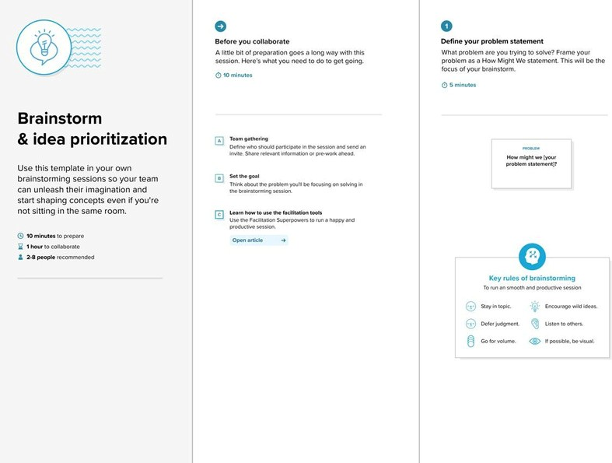
Brainstorm s Idea Prioritization Template:
Brainstorming provides a free and open environment that encourages everyone within
a team to participate in the creative thinking process that leads to problem solving. Prioritizing volume over value, out-of-the-box ideas are welcome and built upon, and
all
participants are encouraged to collaborate, helping each other develop a rich amount of
^{creative solutions.}Reference: https://www.mural.co/templates/brainstorm-and-idea-prioritization
Use this template in your own brainstorming sessions so your team can unleash their Step-1: Team Gathering, Collaboration and Select the Problem Statement imagination and start shaping concepts even if you're not sitting in the same room.
Step-2: Brainstorm, Idea Listing and Grouping
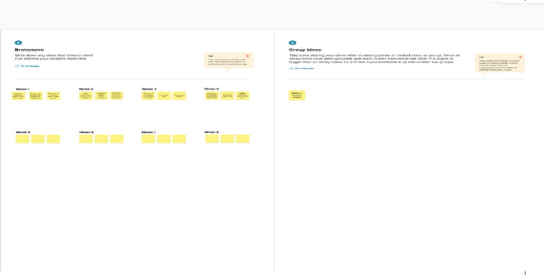
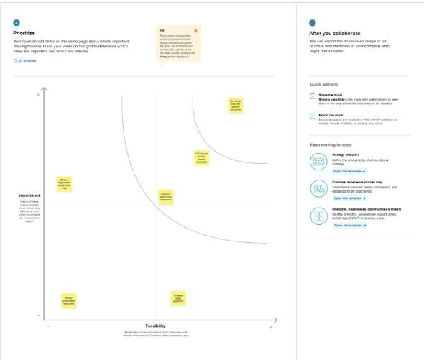
Step-3: Idea Prioritization

